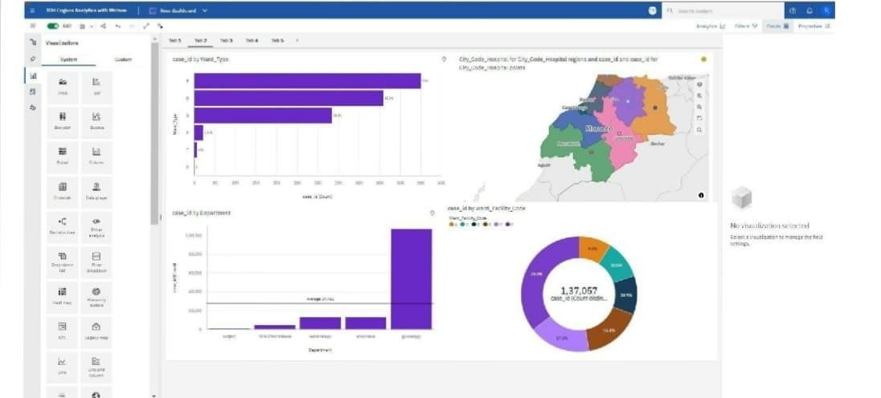



**Dashboard T**

**o**

**Sho**

**w Number Of Patients**